**Developer’s Guide**

**Last modified: May 4, 2018**

# Introduction

This document is to provide basic knowledge to developers in order to maintain or use the system in future.

# Page Flow Diagram

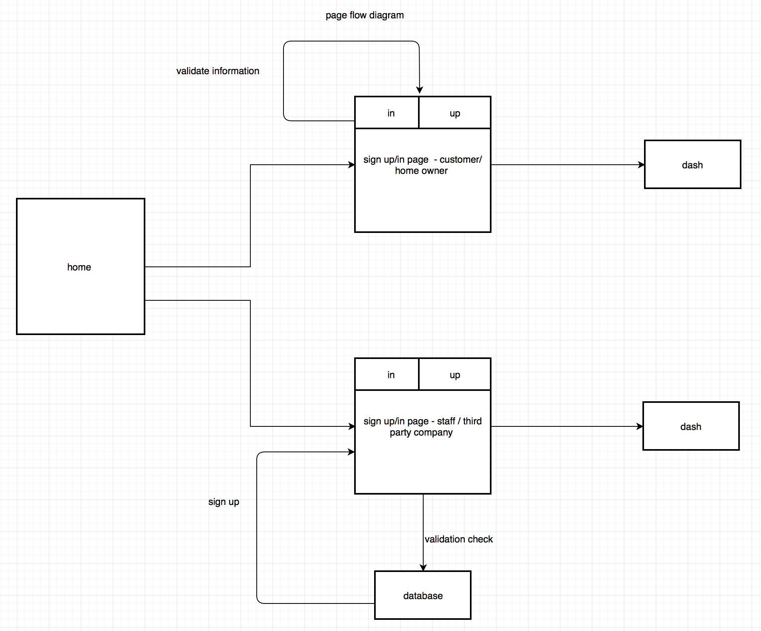

This diagram shows flow of all pages and all considered conditions.

# Class Diagram

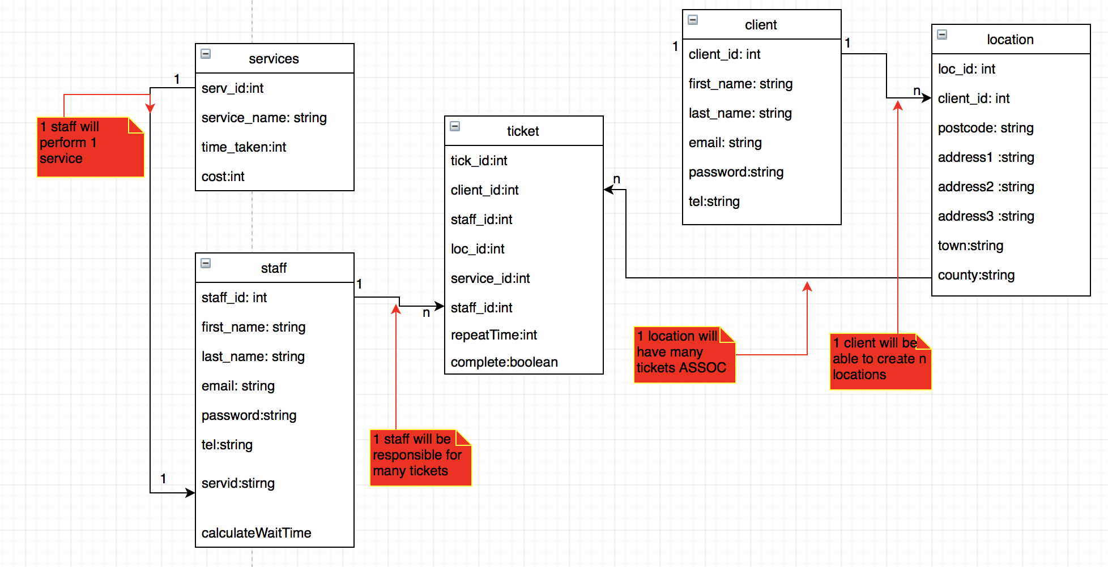

# Code

The system been coded in PHP and HTML. In addition, CSS is being used to style the system, SQL for database and HTMLUNIT Selenium for Tests. All cookies save in encoded form on the browser and all information on customer is also in encoded form in databases to make system more secure. Connection.php file is used to make connection with databases.